

**Final Year Project Report**

**Bachelor of Engineering**

**USB Spectrometer**

Student:

GUID:

1st Supervisor: Hasan Abbas

2nd Supervisor:

2020-21

**Coursework Declaration and Feedback Form**

*The Student should complete and sign this part*

|  |  |  |
| --- | --- | --- |
| Student  Name: | | Student GUID: |
| Course  Code: UESTC4006P | | Course  Name: INDIVIDUAL PROJECT 4 |
| Name of  1st Supervisor: Hasan Abbas | | Name of  2nd Supervisor: |
| Title of  Project: USB Spectrometer | | |
| **Declaration of Originality and Submission Information** | | |
| *I affirm that this submission is all my own work in accordance with the University of Glasgow Regulations and the School of Engineering requirements*  Signed (Student):  ***I affirm this submission is completed by the student independently and the quality of the submission meets the requirements for graduation. I consent to the student taking part in the oral presentation.***  Signed (1st Supervisor): | | C:\Users\kz9a\Downloads\barcode.gif |
| Date of Submission: April / 23 / 2021 | | |
| *Feedback from Lecturer to Student – to be completed by Lecturer or Demonstrator* | | |
| Grade Awarded:  Feedback (as appropriate to the coursework which was assessed): | | |
| Lecturer/Demonstrator: | Date returned to the Teaching Office: | |

# Abstract

This report is about to design and build a Czerny–Turner spectrometer that works at visible light and near-infrared range (400 to 1000 nm), with at least1 nm of resolution and in low cost of less than 2,000 CNY (about 300 USD). An optical simulation software is used to check the feasibility, the case and the framework are built by 3D printing.

For the software part, Python3 is chosen as the programming language and many open-source libraries like NumPy, Matplotlib, and OpenCV are used for data processing and graph rendering.

# Acknowledgements

First of all, I am very grateful to my project supervisor Dr Hasan Abbas for his guidance and suggestions on both the project research and academic writing, and I am especially thanks for his weekly meetings which supervised and urged me on the process of the project, without this, I won’t be able to finish the project on time.

And I wise to thanks my friend Yange Wang for helping me paint the 3D printed case with his professional model making skill. He was doing it for me without proper protection and at the risk of health damage. I hope he did not be hurt by the toxic paint.

After that, I want to thank my friend Wenxiang Li, for helping me do the handcrafting things, going along with me to collect the experimental data and giving me inspiration on optimising the data analysis code.

Then I would like to give my thank to my friend and roommates Heyun Yan for helping me understand the mathematical principle and giving me inspiration on estimation algorithm.

And then, I wish to especially thank Dr Liming Yao and Dr Qunyu Chen in the Department of Physics of UESTC, who generously lent the various light source in their laboratory and gave me advice on the spectrometer building.

After that, I am grateful to my roommates, who tolerated the noise and light pollution that I made for writing the report in the middle of the night.

Then, I want to thank the University of Electronic Science and Technology of China (UESTC) and the University of Glasgow for giving me all the resource in the laboratory and software license that I used in the project.

And then, I want to give my thank to my family for support me emotionally and financially.

At the last, I wish to thank all the people and organizations that give me any support and I do not mention it above.

Contents

Abstract 4

Acknowledgements 5

1 Introduction 8

1.1. Technical Background 8

1.2. Project Objective 9

2. Theory 10

2.1. Diffraction Grating 10

2.1.1. Physics of Diffraction Grating 10

2.1.2. Grating Equation 13

2.2. System Resolution 14

2.2.1. Diffraction Limitation and Rayleigh Criterion 14

2.2.2. Chromatic Resolution 16

2.2.3. Width of Slit’s Image 17

2.2.4. Sensor’s Physical Resolution 17

2.3. Linear Dispersion 17

2.4. Colour Space Standard 19

2.4.1. sRGB Standard 19

2.4.2. CIE XYZ Standard 20

3. Design and Build 22

3.1. Hardware Design 22

3.1.1. Geometric Structure 22

3.1.2. Collimation Mirror and Slit Design 23

3.1.3. Incident Angle Choice 24

3.1.4. Camera Angle Choice 25

3.2. Component Choice 25

3.2.1. Grating Choice 25

3.2.2. Camera Choice 27

3.2.3. Mirror Coating Material Choice 28

3.2.4. Others 29

3.3. Optical Simulation 29

3.4. 3D Model Building and Printing 31

3.5. Assembling 32

3.6. Software Building and Calibration 33

3.6.1. Data Capture and Processing 33

3.6.2. Linear Calibration 34

4. Discussion and Results 38

4.1. Result of the Measurement 38

4.2. Verification of the Project 40

5. Conclusions and further work 42

5.1. Conclusions 42

5.2. Suggestions for further work 42

Reference 43

A. Appendices 45

A.i. Specification list 45

A.ii. Component list 45

A.iii. List of Figure 45

A.iv. List of Equation 46

A.v. Code 47

A.v.a. Main Program 47

A.v.b. Matlab Codes for Figure 3‑2 48

A.v.c. Matlab Codes for estimation algorithm in Section 3.6.2 49

# Introduction

## Technical Background

Spectroscopy is a study of the interaction between matter and electromagnetic radiation based on the function of the frequency and other chrematistics, and it is the fundamental research tool in many areas like physics, chemistry, astronomy, and many more.

For example:

* In astronomy, we compare the wavelength difference in the spectrum to measure the velocity of the interstellar object by the Doppler effect and discover the redshift.
* In chemistry, we measure the relative strengths of the emission and absolved lines in the spectrum to find the constitution and abundances of the targeting material.
* In physics, spectroscopy is the core of quantum physics, it could be used to analyse the structure in the microcosmic area and many physics mechanisms.
* And many other fields like the medical analysis.

In spectroscopy, an optical spectrometer is usually the basic measurement instrument, it measures the radiation intensity of the incident light as a function of wavelength by separating and capturing the different frequency components. And due to the importance of spectroscopy, an optical spectrometer is one of the essential instruments in many above-mentioned research areas. However, a basic complete optical spectrometer solution may cost more than 3,000 USD without counting the software license fee and technical support, some manufactures even request more than $10,000 [1]. The price is unacceptable for the third world poor laboratories, education institutions, and personal enthusiasts so that it is important for them to have instructions to build their own spectrometer and software in low price (less than $300) and acceptable accuracy.

However, building a spectrometer is not an easy task, it requires knowledge and skills in many subfields of science and engineering, for instance, optics, electronic engineering, image processing, and programming skills. Furthermore, it requires the designer to balance each characteristic of the system, consider the trade-off of them and make the decision under limits. And there is very little information through which one can quickly get up to date with the subject and start building a spectrometer with high resolution and low cost, the solutions that could be found online are whether required expensive instruments or not having acceptable accuracy. So, this project is an effort to fill that void and generate knowledge through which one can build a low-cost spectrometer.

## Project Objective

This project intends to build a high-solution spectrometer in low cost. The wavelength coverage should be at visible light and near-infrared range (400 to 1000 nm), and the resolution need to be at least 1 nm of the resolution and the total cost of the project should be less than 2000 CNY (about 300 USD), and an accessory software for the data processing and plotting the spectrum intensity diagram should also be included the project.

# Theory

This section of the report describes the principles and theories that are necessary to understand for designing the hardware instrument as well as the algorithm for software designing.

## Diffraction Grating

The core component in the Czerny–Turner Spectrometer design is the diffraction grating. It is the part that spread the different frequency component and then is processing by other parts. So, it is very important to understand the principle of how the grating works, its characteristics, and its performance in the optical system.

### Physics of Diffraction Grating

Generally speaking, a diffraction grating is a periodic structure of reflective surfaces or transmissive slits which are placed on a plane. According to the Huygens–Fresnel principle, every point on the wavefront can be seen as an independent source (see Figure 2‑1) [2]. In this case, we regard the slits as the sources, and in some direction, the wave will add up or cancel each other and form a diffraction pattern on the screen.

Figure ‑

(Demonstration of Huygens–Fresnel principle)

For more specifical analysis, an example [3] is given:

G

$$L_{1}$$

$$L_{2}$$

S

P

Figure ‑

(Example of Fraunhofer grating diffraction)

* In Figure 2‑2, S is the signal slit acting as the light source and placing on the focal plane of $L_{1}$. Assuming the slit is infinitely thin, so that light after $L_{1}$ will be parallel. G is the grating, it has N slits with a width, and the width of the non-transparent part between two slits is b. The parallel light after the grating will be focused to P point which is on the focal plane of $L_{2}$.
* Firstly, starting with the single slit situation like in Figure 2‑3, if the $dx$ represents the width of the unit sub-wave, and vibration caused by this sub wave can be written as

(‑)

**

Figure ‑ [4]

(Example of Fraunhofer single slit diffraction)

In the above equation, $r_{0}$ is the distance between point $O$ to $P$, $C’$ is a constant, $Δ$ is the optical path difference (OPD) between point O to P and arbitrary point C to P. If we assuming the lens $L_{2}$ is perfect, $Δ$ will only be determined by angle $θ$, i.e., $Δ=xsinθ$. Then we add up all the sub-waves so that the wave on point P is:

(‑)

* Back to the multi-slit grating, we add up vibration caused by all the slits:

(‑)

After integration and manipulation of the above equation, we obtain:

(‑)

Where , and $v=\frac{\left[π\left(a+b\right)sinθ\right]}{λ}$. Then we can find the amplitude as well as the intensity equation:

(‑)

(‑)

Coincidentally, the factor $\frac{\sin^{2}{u}}{u^{2}}$ is the intensity distribution function of the single slit Fraunhofer diffraction, and the other factor $\frac{\sin^{2}{Nv}}{\sin^{2}{v} }$ is the intensity distribution function of multi-beam interference. Obviously, the grating diffraction is the multiplication of two, in the other words the grating diffraction is the multi-beam interference modulated by the single slit diffraction, and we can discover this in the diagram of these functions too. (Figure 2‑4)



Figure ‑ [3]

(Demonstration of intensity distribution function)

### Grating Equation

As mentioned in Section 2.1.1, the intensity distribution function of multi-slit Fraunhofer diffraction is:

(‑)

If we only consider the multi-beam interference effect, it is easy to find that the intensity is maximum when $v=kπ$. So that when it satisfied the equation below, there will be the corresponding bright fringe.

(‑)

And this is what we usually called grating equation, the left side $\left(a+b\right)sinθ$ represents the OPD of two adjacent beams at the direction of $θ$. However, this equation only illustrates the perpendicular incidence situation, for more universal condition, the grating equation is:

(‑) [3]

Where $φ$ is the angle between incident light and normal of the grating, and $d=a+b$.

Besides the maximum bright fringe, the distribution equation of the minimum dark fringe is also important. Similarly, only considering the multi-beam interference effect, when $v=\frac{k^{'}π}{N}, k^{'}≠N, 2N, 3N…$, the intensity at the direction of $θ$ is zero. So, we obtain:

(‑)

Or more universally:

(‑) [3]

## System Resolution

Resolution is a very important characteristic of an imaging system, it describes how precisely the system recording the information. In this case, we mainly talk about the chromatic resolution, that is the capability of the system to distinguish the minimal frequency difference. This capability of the system is mainly related to the following factors:

* Chromatic resolution of the grating
* Imaging resolution caused by the aperture diffraction limit
* The width of the slit’s image on the sensor
* Sensor’s physical resolution.

The system resolution depends on the worst scenario, and they are illuminated in the following part.

### Diffraction Limitation and Rayleigh Criterion

In wave optic theory, the image formed by the optical system is actually the diffraction pattern of the incident light beam through the system, it depends on the size and shape of the aperture and the frequency of the light. By rough analysis, the point image could be considered as the Airy disk (i.e., the central bright spot) of the Fraunhofer diffraction.

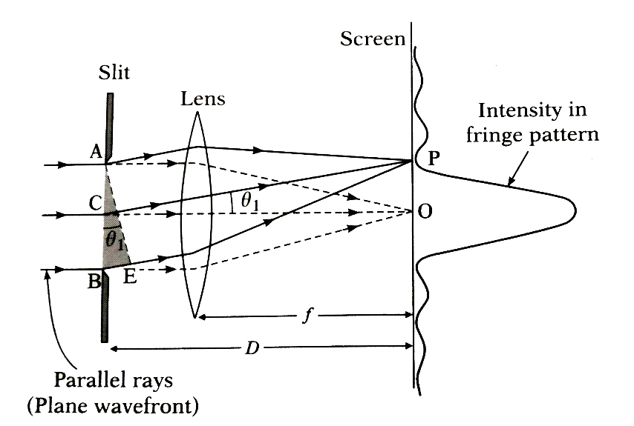

Figure ‑ [5]

(Example of Fraunhofer single slit diffraction)

From Figure 2‑5 [5], It is easy to discover that the image of two beams will be impossible to distinguish when the angle between them is too small, because their Airy disk will overlay each other, like the situation in Figure 2‑6 [6](c).

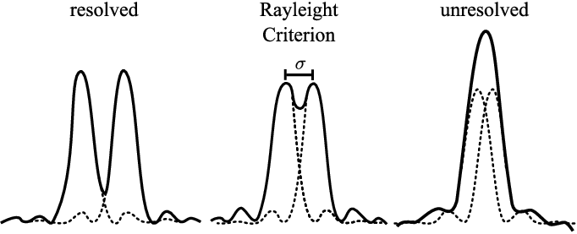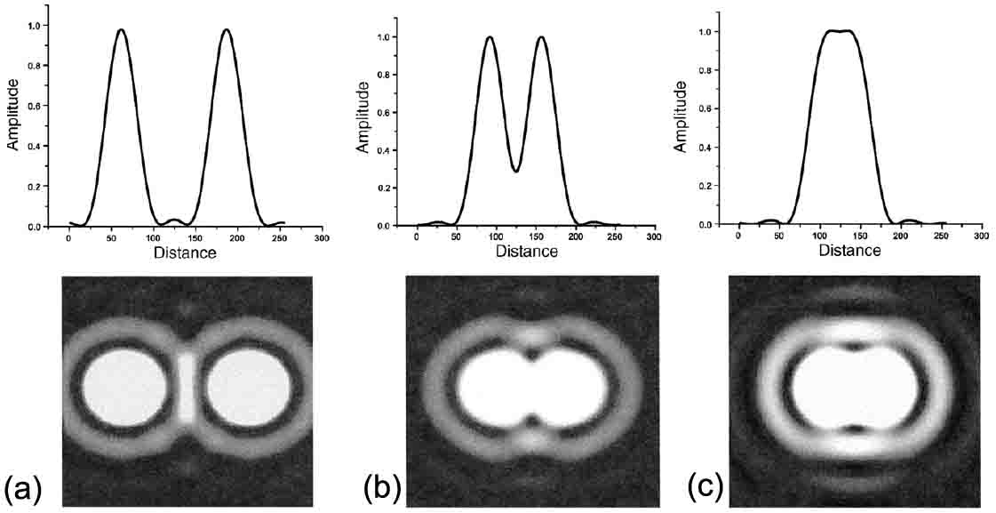

Figure ‑ [6]

(Demonstration for Rayleigh criterion)

And in Figure 2‑6 [6] (b), when the centre of the first bright spot and dark spot line up, we are just able to justify the two beams, and this condition is called the Rayleigh criterion. For a round aperture optical system with parallel light beams, this criterion means the minimal adjustable angle of two beams is:

(‑) [7]

The a is the aperture size, and this is the angular resolution of an optical system.

### Chromatic Resolution

If we assume a situation that the kth order bright fringe of wavelength $λ$ light lines up with the kth order dark fringe of wavelength $λ+δλ$ light (like in Figure 2‑7), it just satisfies the Rayleigh criterion that is illustrated in Section 2.2.1, which means the best chromatic resolution of the grating, we often quantified it as:

(‑)



Figure ‑

(Example of Rayleigh criterion in chromatic dispersion)

In Section 2.1.2, we obtain the maximum and minimum grating equation, Equation 2‑9, Equation 2‑11. If we combine these two equations, we could get the equation of Figure 2‑7 situations, that is:

(‑)

(‑)

So the chromatic resolution of the grating is：

(‑)

### Width of Slit’s Image

In the previous section, we assume the slit is infinitely thin to simplify the analysis. However, in any practical optical system, the aperture size cannot be infinitely small, because of the obvious reason, it will block all light to path through. So, in the actual design, we have to consider the effect of the slit’s width and how it affects the resolution. However, precisely analyse this effect is too complicated and far from the main topic, so here only the approximate equation is given:

(‑)

### Sensor’s Physical Resolution

Like any digital camera today, there is a limited number of pixels on the detector, and their size is also limited. So, the resolution that the detector can detect is limited. Even more, because the spectral line cannot always perfectly line up with each sensor on the detector, the resolution quality is actually worse than the physical resolution (see Figure 2‑8).

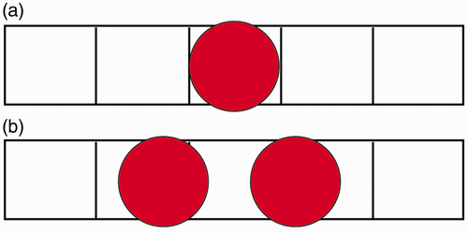

Figure ‑ [8]

(The grids represent pixels; the circles represent image points)

However, for any complementary Metal-Oxide-Semiconductor (CMOS) detector in the camera today, the pixel size is usually 10 times smaller than the optical dispersion resolution, so that the influence of this effect can be ignored.

## Linear Dispersion

In Section 2.1.2, the physical principle and the angular dispersion rule of the diffraction grating are illustrated and analysed. However, the CMOS sensor on the camera is not a sphere, but a flat plane. This leads to the problem of how to map the graphic data to the corresponding wavelength or in the other words finding the linear dispersion equation. For better understanding a simple diagram of Czerny–Turner spectrometer is drawn in Figure 2‑9, more detailed analysis is in Section 3.2.1.

**S**

$$M_{1}$$

$$L_{2}$$

**G**

**D**

$$α$$

$$β$$

$$θ$$

$$∆x$$

$$γ$$

$$φ$$

Figure ‑

(Example of Czerny–Turner spectrometer)

In the above Figure 2‑9, $S$ is the single slit, $M_{1}$ is the concave collimation mirror, **G** is the grating, $L_{2}$ is the focusing lens and **D** is the detector. **S** is placing at the focal point of $M_{1}$, $∆x$ represent the shifting distance of the slit image on the detector.

For an ideal camera lens, we have Equation 2‑18 to describe the relationship between the angle of incident light and image position [9].

(‑)

After the integration, we get:

(‑)

In Figure 2‑9, we can easily see:

(‑)

Combining these equations and Grating Equation 2‑9, we have:

(‑)

At this point, we find the linear distribution equation of the spectrometer.

## Colour Space Standard

The light spectrum in the physical world is continuous which means there are infinite number of the spectrum line in just one beams of light. If we ever want to log this light information, we need to store the infinite number of spectrum line and their intensity which is not acceptable in any digital system. However, the human eye does not do it either, there are only 3 types of cone cells on the human retina and each of them has an identical spectrum sensitivity. So, it is possible to use a 3-dimensional vector of the infinite spectrum’s projection to fully recode and reproduce the intensity and colour information that human eyes could distinguish. This 3-dimensional vector space is called the colour space, and there are various standards of it.

However, in this spectrometer design, we do not need the colour information, and it even causes the problem on recovering the luminance information, because they are usually been linearly or non-linearly transformed. So, it is important to fully understand these standards and find the algorithm to inversely transform the vector back to luminance.

### sRGB Standard

Standard Red Green Blue colour space (sRGB) was developed by HP and Microsoft cooperatively in 1996. It was designed to be used on the screen, print and Web development, and it did become the most popular colour space and the standard for the media content on the Internet, and most digital cameras that we plan to be used in this project are using this standard.

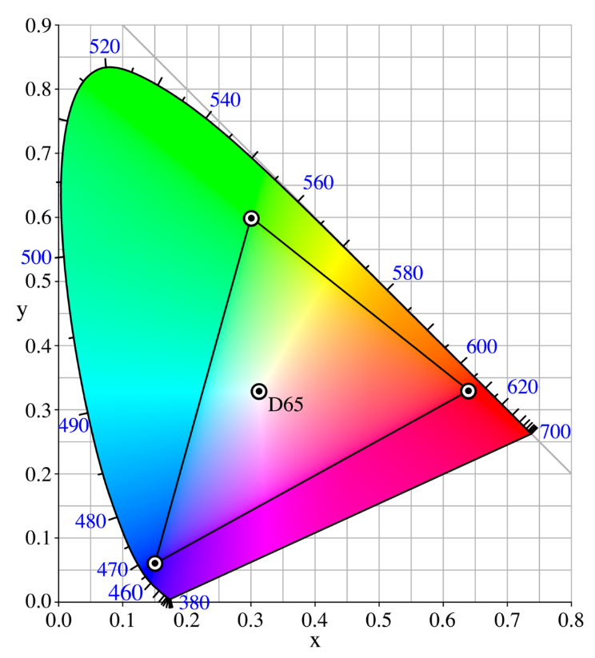

Figure ‑ [10]

(The central triangle is the sRGB colour space, and the outer round triangle is CIE XYZ)

sRGB is not a linear space, the RGB three values have been Gamma compressed to save the storage space and dynamic range because human eyes do not have linear sensitivity on luminance. So, to recovery the original luminance information, we need to first do the inverse operation to decompress it and transform it to a linear space. The following equation is for the Gamma decompressing.

(‑) [11]

（Where u is the R, G, and B）

### CIE XYZ Standard

CIE XYZ colour space is the first colour space that is defined mathematically. It was created by International Commission on Illumination (CIE for Commission Internationale de l'éclairage in French) in 1931. It is still widely used today for its wide coverage of colour. It is a very old standard, the electrical computer had not been invented at that time so that to make the calculation simple enough to do by hand, it is linear space, and even approximate, the Y component in the vector directly represents the relative luminance which is what we want.

To convert the sRGB to CIE XYZ colour space, we firstly take what we get from Gamma decompressing in Equation 2‑22, and then do the following matrix multiplication:

(‑) [11]

And then taking the Y component, we get the relative luminance [12].

# Design and Build

This chapter contains all the detail and process that is made during the project designing and producing. And how to achieve the whole project from scratch, from component choosing, hardware design, to simulation, building and finally making out. Hope the experience knowledge in this section will help you a lot from not walking the same curve road again and make your own spectrometer.

(Due the complexity and speciality of component purchase and building, the section 3.2 to 3.6 may include some subjective perspective and personal experience that cannot be quantified, and I do not endorse any brands and product that is mentioned in these sections.)

## Hardware Design

### Geometric Structure

In this spectrometer design, A classical and widely used structure called Czerny–Turner spectrometer is used. Basically, it has 6 main components, which are light source, single slit, collimating mirror/lens, diffraction grating, focusing mirror/lens and detector [13]. The light source is what we want to measure, and it is aimed at the single slit. The slit is placed at the focal plane of a collimating concave mirror or a convex lens so that the light from the slit re is collimated and become parallel light. Then the collimated light is diffracted by the grating and is collected by another mirror or lens called a focuser, which refocuses the light and project on the detector. And then the signal is transmitted to a computer and showing the spectrum intensity data to the user by the graph (see Figure 3‑1).

**S**

$$M_{1}$$

$$α$$

$$γ$$

$$L_{2}$$

**G**

**D**

$$θ$$

$$φ$$

Figure ‑

(Example of Czerny–Turner spectrometer)

There are plenty of characteristics that could be adjusted and optimised, like the width of the slit, the geometric of the mirror and lens, the angles between their normal and so on. For simplifying optical system design and improving image quality, a digital camera and its lens is chosen to be used in the focus lens and detector. And customized diffraction grating is usually very expensive, so using the grating that already exists on the shelf is a better idea. The method of how to choose these two components is in Section 3.2, and this section will focus on the rest of things’ design.

### Collimation Mirror and Slit Design

In Section 2.3, the linear distribution rule of the spectrum is summarized by Equation 2‑21. And we could use it to get the minimal slit image width for a giving centre wavelength and spectrum resolution:

(‑)

(‑)

(Where is the centre wavelength and $∆λ$ is the spectrum resolution)

Then in Section 2.2.3, the relationship between the slit’s image width and physical slit width is summarized by Equation 2‑17. And assuming the magnification $M=\frac{F_{focuser}}{F_{collimator}}$, we could get the relationship between slit width and the focal length of collimator:

(‑)

In my case, the centre wavelength is 806nm, $α=0$, $φ=0.93 rad$, $d=1*{10}^{-6}m$, $k=1$, and $∆x=1nm.$ So we obtain that:

(‑)

For simplifying the manufacture and reducing cost, it is decided that $w_{s}=0.1mm, F_{M_{1}}=110mm$ and it is satisfied the Equation 3‑4. And the height of the slit is 15mm and the size of the collimator is $50*25.4*6.7 mm$, they are decided by the manufacturer or the size of the spectrometer.

### Incident Angle Choice

From the Grating Equation 2‑9, we could know that the incident can affect the diffraction angle range, and this effect is not linearly. So, rearrange the equation and we get the relationship between these two factors:

(‑)

Then, use Matlab to draw the diagram between $∆θ$ and $α$ in Figure 3‑2.



Figure ‑

(Diagram between ∆θ and α)

From Figure 3‑2, it is obvious that in my setup, the zero-incident angle could bring the maximum diffraction range.

### Camera Angle Choice

The range of the wavelength for this spectrometer is $400-1000nm$, by the Grating Equation 2‑9 and the zero-incident angle mentioned in Section 3.1.3, the range of diffraction angle can be got as $17.45°-90°$. Then use the centre of this range to directly aim at the camera, so the camera angle $φ$ is $53.725°$ or $0.9376 rad$.

## Component Choice

The choice of the component is very important in designing and building a spectrometer, it requires the components fitting both the specification of the design and financial budget at the same time. It is not an easy task, you need to have the basic knowledge and technique in the corresponding area. A good project management skill or experience in related components choice may help but lots of trial and error or even sacrifice of instrument performance is still not evitable.

### Grating Choice

According to the fabrication method, the diffracting can be classified into the following type:

* Ruled grating, which is made by ruling tons of grooves on the surface of the plane glass.
* Duplicated ruled grating, which is made by using a high-quality ruled grating as moulds and using the resin to copy the original grooves on the grating.
* Holographic grating, it uses the light cure resin to capture the dual monocolour laser interference pattern which is an equal-interval-fringe pattern. And after washing away the uncured resin, the remaining part forms the equal-interval-groove structure, that is the grating. It is similar to the photolithography in silicon chip’s fabrication.

The ruled grating and the duplicated one have the advantages on large grating size (more than a square meter) and curved surface fabrication. However, these advantages are not what we needed, we only require a plane grating with a few square centimetres size. So that a holographic grating is chosen for the advantage of the high-groove-density to bring the high chromatic resolution, and more importantly much cheaper price. The same size and density holographic grating usually cost 100 times less than a duplicated rule grating and even more than the original one, for a low-cost solution, it is very important.

Then, the grating has the transparent and reflected type, either of them is fine to choose. The reflected one is usually 50% more expensive than the transparent one but giving more freedom on optical path design. If you are using a transparent grating, the incident angle mentioned in Section 3.1.3 should be zero to prevent refraction and chromatic dispersion before the grating. And the side of the transparent grating may capture the stray light causing unwanted noise, so the extra stray light-absorbing solution may be introduced. In my case, the incident angle is designed to be zero, so the transparent one is chosen to save the budget.

And then, for the density of grating, the choice is highly customizable, and there is no one-to-all solution, the designer should decide this parameter base on their own demands and manufacture availability. For example, the intended wavelength range for my project is 400-1000nm, so that the grating density cannot beyond 1000 lines/mm, otherwise the diffraction angle of the near-infrared light will be more than 90 degrees (see Section 2.1.2 and Equation 2‑9)which is not practical. And my grating manufacturer sells 500-1000 lines/mm grating at the same 150 CNY (around 23 USD) price, so the top 1000 lines/mm one is selected for the best chromatic resolution.

By the way, if the budget of your project is really tight, the disused DVD optical disk could be used to replace the diffraction grating. Each track could work as the groove on the grating, and it comes with the reflected surface. Although the curved track may bend the final spectrum image, it actually does not affect the measurement. The distance between the two tracks is usually 0.74 um [14].

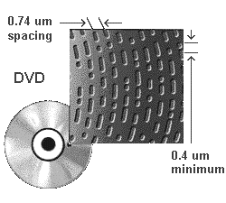

Figure ‑ [14]

(Tracks on the DVD)

### Camera Choice

The best camera choice for this low-cost spectrometer project should be a second-hand digital single-lens reflex camera (DSLR) or mirrorless interchangeable lens camera (MILC). They usually have a relatively large-size high-resolution CMOS sensor (24.89 × 18.66 mm for an Advanced Photo System type-C (APS-C) sensor), RAW image output function, and the large aperture size lens with adjustable focal length in the bundle, all these features could either improving the image quality, chromatic resolution or simplifying the designing process, and you can get one for just around 700 CNY (110 USD) [15] (price might be variable in your location) in the second-hand market. For example, the SONY a5000 or Nikon J1.

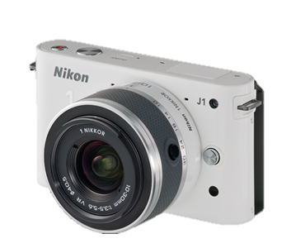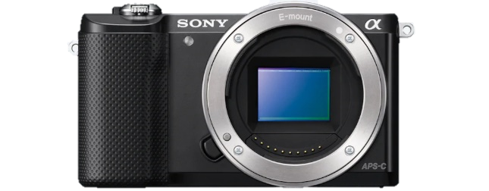

Figure ‑ [16] [17]

(Picture of SONY a5000 or Nikon J1)

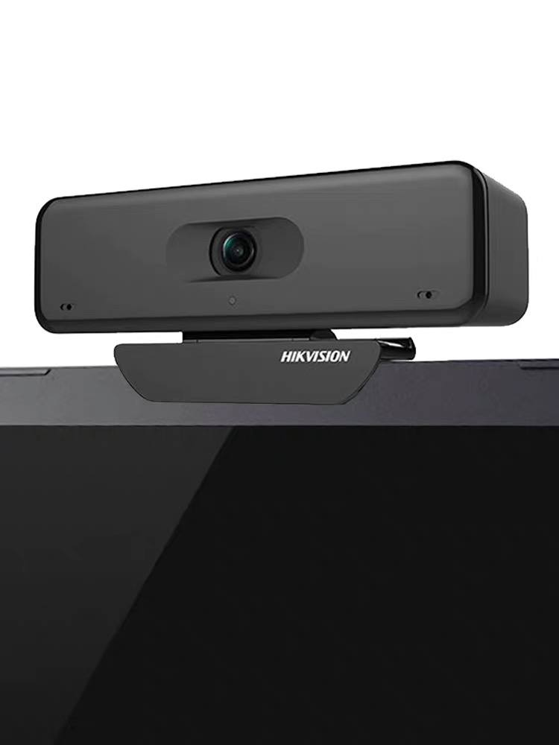

Figure ‑ [18]

(Picture of HIKVISION webcam)

However, the camera that is used in this project is HIKVISION DS-2CS54U0B-SD (see Figure 3‑5 [18]), a webcam with only 6.4 × 3.6 mm size, fixed low-quality small-aperture lens, sRGB compressed output, and only 3840 × 2160 resolution. Although the price is lower in 500 CNY (77 USD), the price-quality ratio is actually much worse than the product that is mentioned above. The reason to choose this camera is the final year project funding system in my campus, they required a taxed receipt as the certification of purchasing component, and it is obviously not something you can get in a second-hand transaction. So, a trade-off must be made to fit the funding requirement, and this a good example of the difficulty that you will face in practical project building.

### Mirror Coating Material Choice

The coating material choice for a mirror is just determined by one characteristic, that is the spectrum reflectance. See Figure 3‑6 [19] below, we can easily find that the UV enhanced aluminium has a consistent over 85% reflectance in the working wavelength (400-1000 nm) which make the attenuation after the mirror stable in each frequency. And it is the cheapest option except for the protected aluminium so that we should choose it.

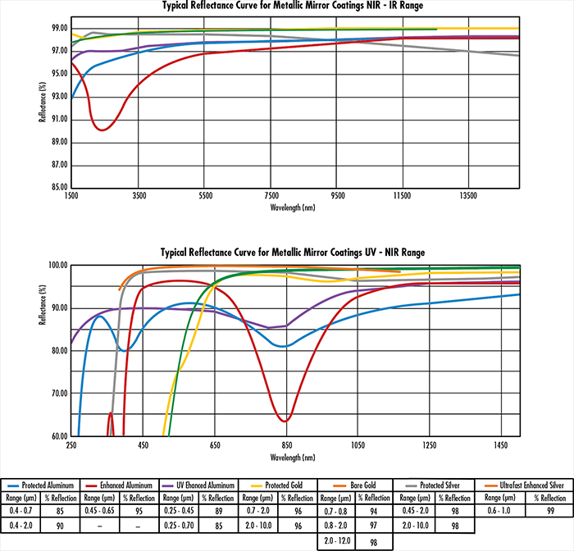

Figure ‑ [19]

(Diagram of Reflectance on different coatings)

### Others

For the slit on the entrance of the spectrometer, a laser cutting steel plate with the blackening processing could be used at it

And after choosing the main component, the work has not done yet. There are some accessory components that could be added according to the requirement. For example, an optical fibre could bring the flexibility of measuring to the instrument, or a sample box for the material spectrum testing.

## Optical Simulation

A clever engineer never starts building a project right after designing it, usually, a recheck and evaluation are required for proofing practicability and predicting the result. Luckily, we are living in a world after the information technology revolution. There is a computer right next to your hands that could do trillions of calculations in just one second, why not using it to do the annoying recheck work? So, in this section, a brief description will be made to demonstrate how to do the optical simulation and how it benefits the design of a spectrometer.

The software that is used for the optical simulation is the Zemax Optical studio. It has a free education version on their website, if you were a student and your university is on the list, you could just download and use it, otherwise, you may need to find another one that is free to use, like OSLO EDU Edition or just Google “Free Optical Simulation Software”.

In Figure 3‑7, we could see that almost all the spectrum lines are perfectly focusing on the detector. And in Figure 3‑8, the frequency of the light source is set to the sodium yellow D-lines (588.9 and 589.5 nm), and it is easy to see the two peaks in the zoomed figure which indicated the spectrometer has more than 1 nm accuracy and pass my objective.

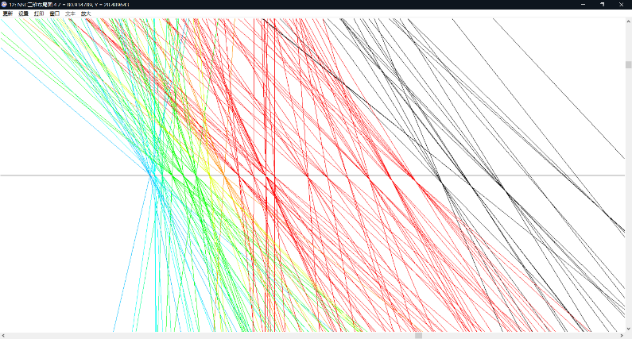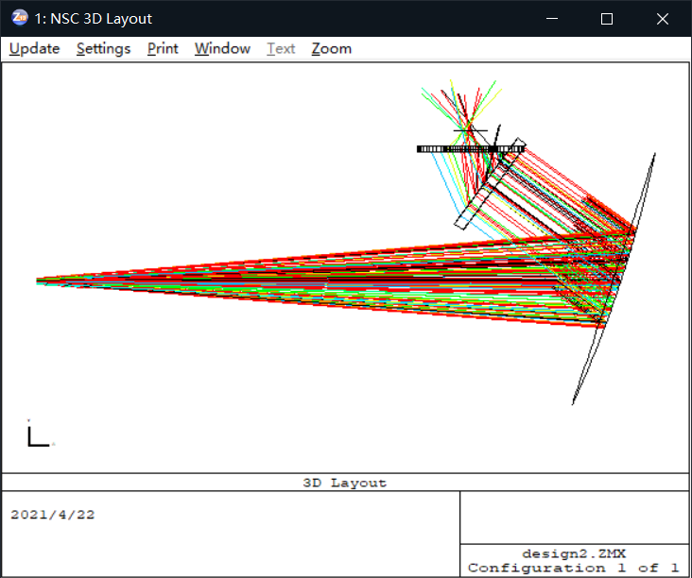

Figure ‑

(the left is ray traced spectrometer layout; the right is the zoom-in of the detector)

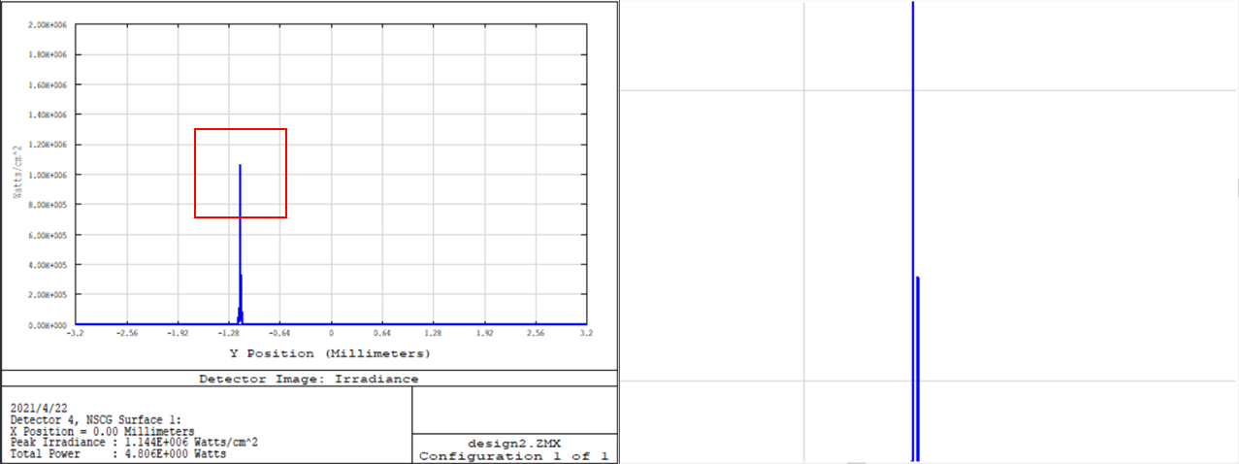

Figure ‑

(the left is detector image in cross-section; the right is the zoom in on the left)

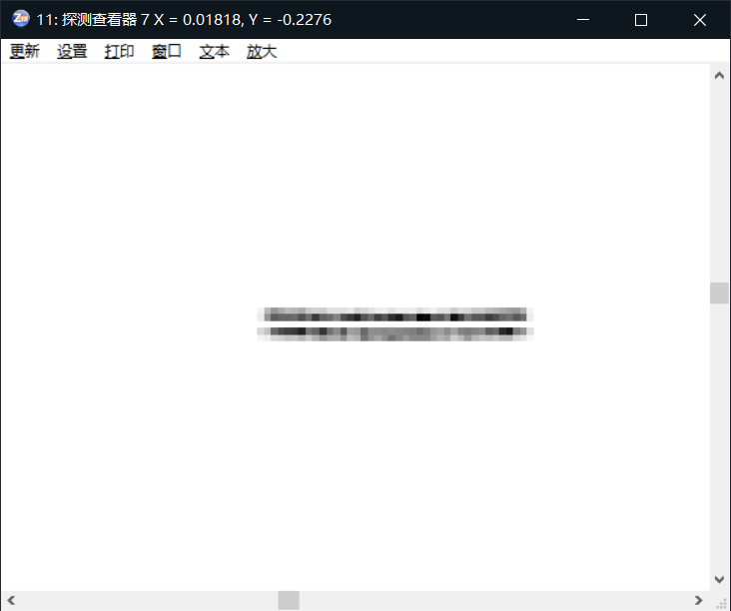

Figure ‑

(Image on the simulated detector)

## 3D Model Building and Printing

3D printing is not necessary in this project, an outer case made of a carton box could also work. However, a high-quality 3D printed model could minimise the inaccuracy in the assembling, improving image quality and reduce time in handcrafting.

The software that is used in this project for the 3d model building is SOLIDWORKS. If you do not have the license for it, you could use AutoCAD which is free for all education usage. Figure 3‑10 shows the model in this project.

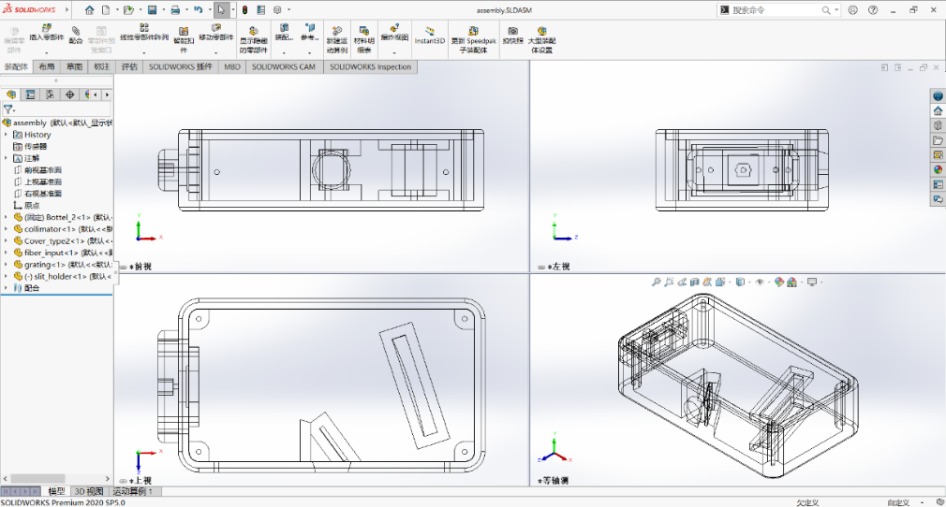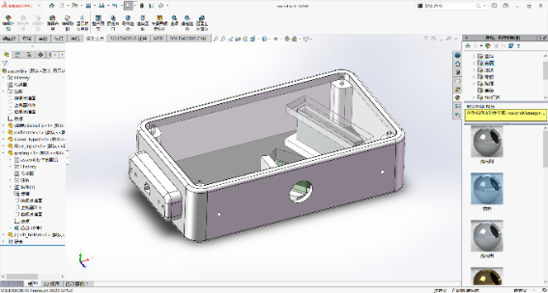

Figure ‑

(Orthogonal drawing of the 3D model)

After building the model, a 3D printer is required to accomplish it in the real world, initially, it is planned to use the one in my campus laboratory, but it was broken just after the first draft model was printed, so that an online 3D printing provider is chosen to print it and ship to me. But it is actually a better solution, the online provider uses stereolithography apparatus (SLA) printer which is much better in surface smoothness, precision, and fabrication time than the fused deposition modelling (FDM) printer in the laboratory (see Figure 3‑11).

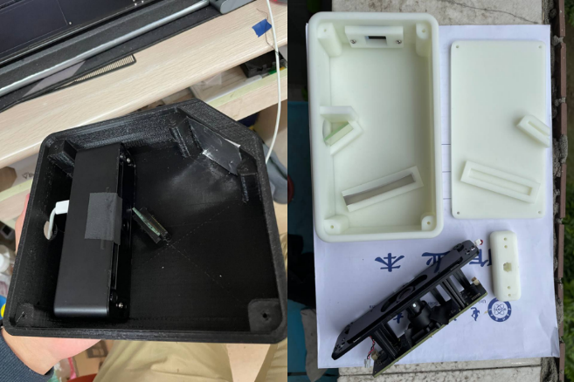

Figure ‑

(The left one is made by FDM; the right one is made by SLA)

But it has a major defect, the material use in SLA is white, and semi-transparent, using it in an optical system is unaccepted, for example in the spectrum image Figure 3‑12, the stray light is too strong to see the spectrum. So that it requires post-processing like painting or light-absorbing stickers to minimize the light bounce inside or penetration into the case. So that it requires post-processing like painting or light-absorbing stickers to minimize the light bounce inside or penetration into the case.

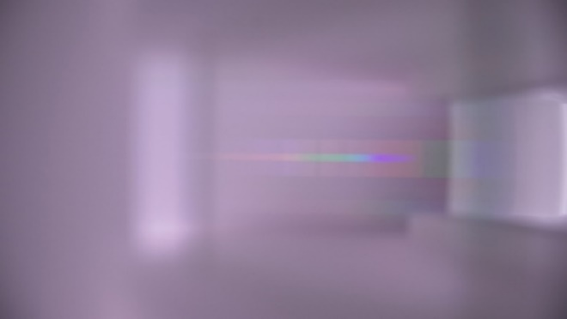

Figure ‑

(The spectrum is covered by stray light)

## Assembling

After all the designing and receiving the component ordered from the manufacturer, it is finally time to assembly the spectrometer. And there are not many physical or mathematical things to say, only some caution and subjective suggestions.

* As mentioned in Section 3.4, if the case is white or transparent, it should be painted black to prevent stray light. During the painting processing, it should be noticed to have good airflow or wear a filter mask, otherwise, the paint may cause serious health problem (see Figure 3‑13).

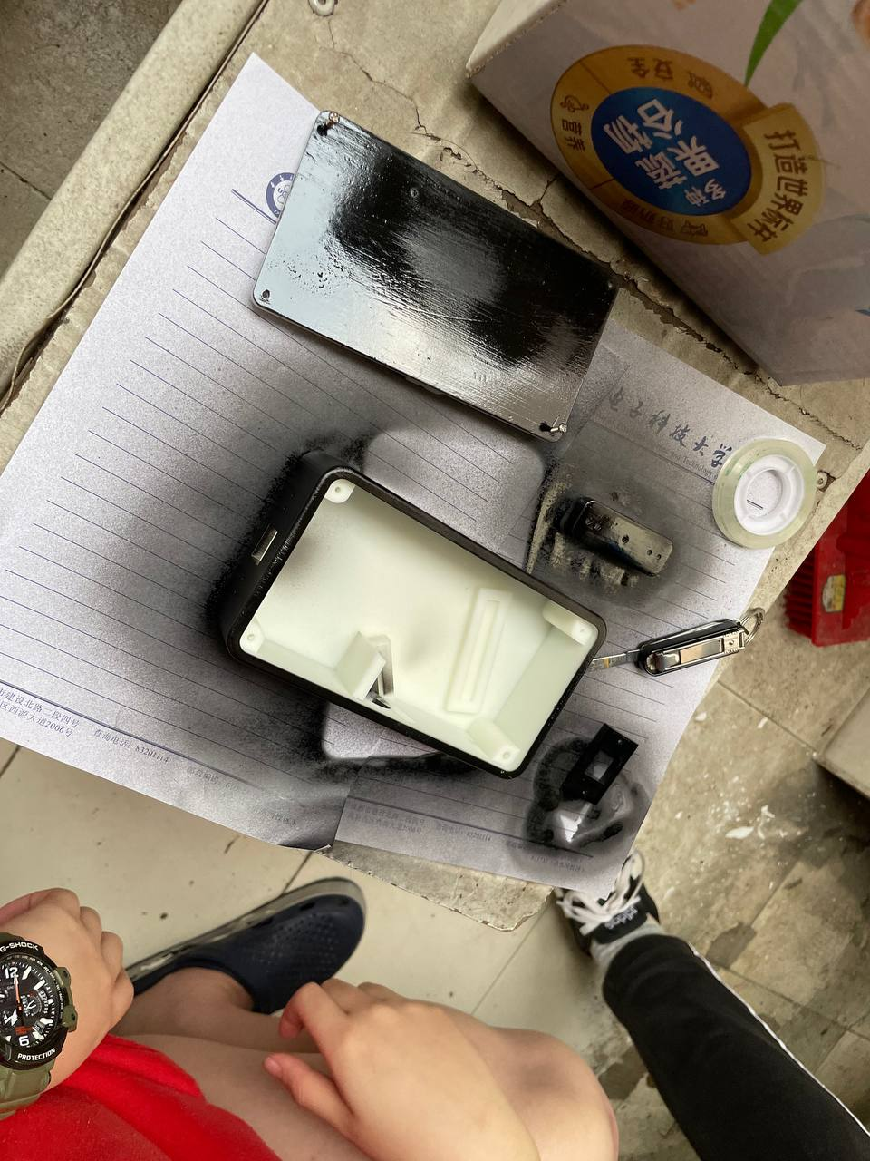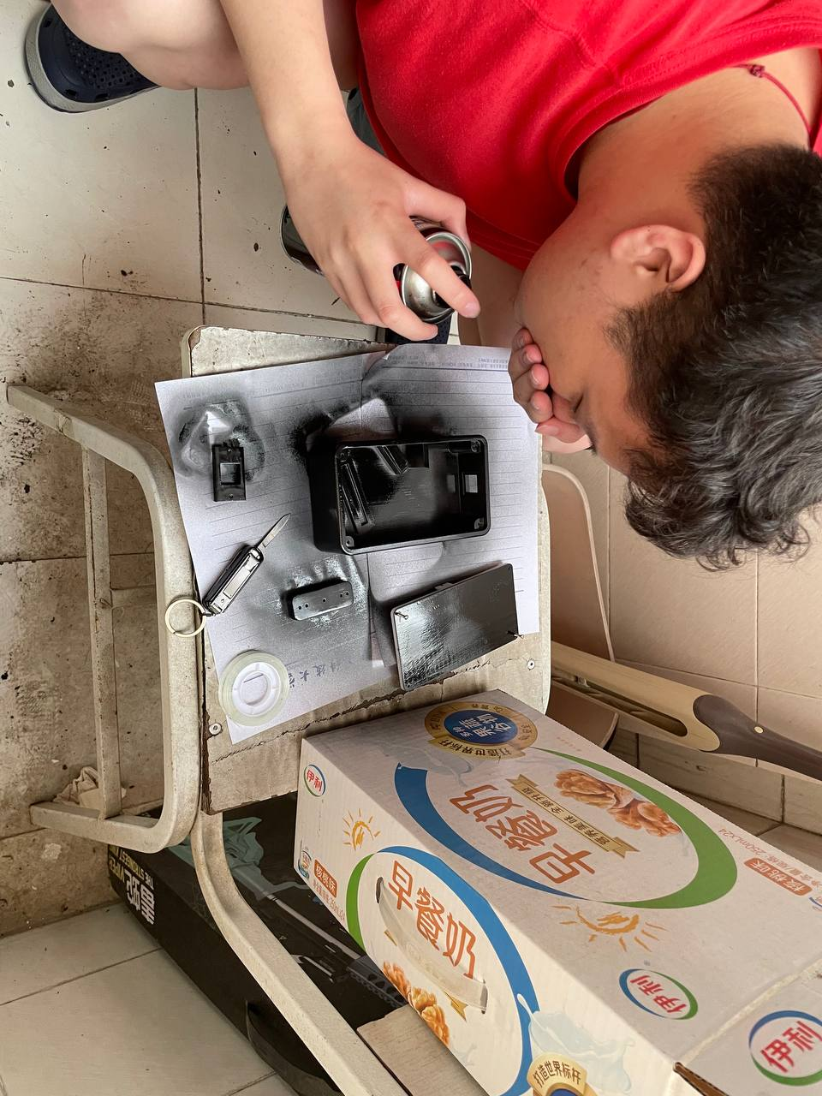

Figure ‑

(Photo of paint process)

* When using the light-absorbing sticker, make sure to reserve the assembling tolerance, otherwise assembling processing might be blocked.

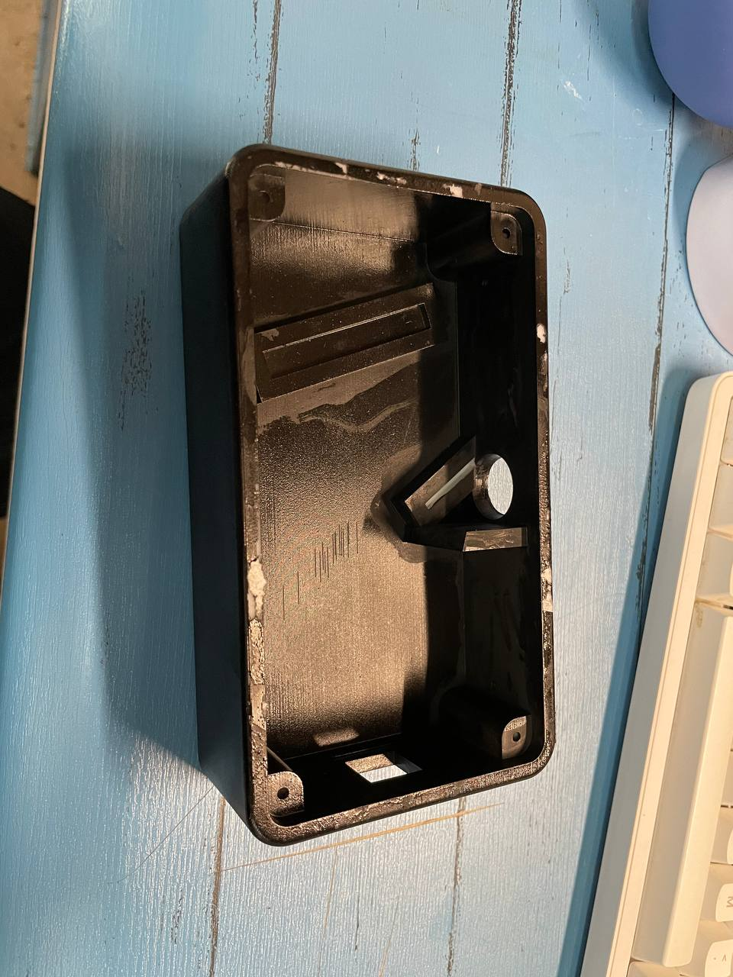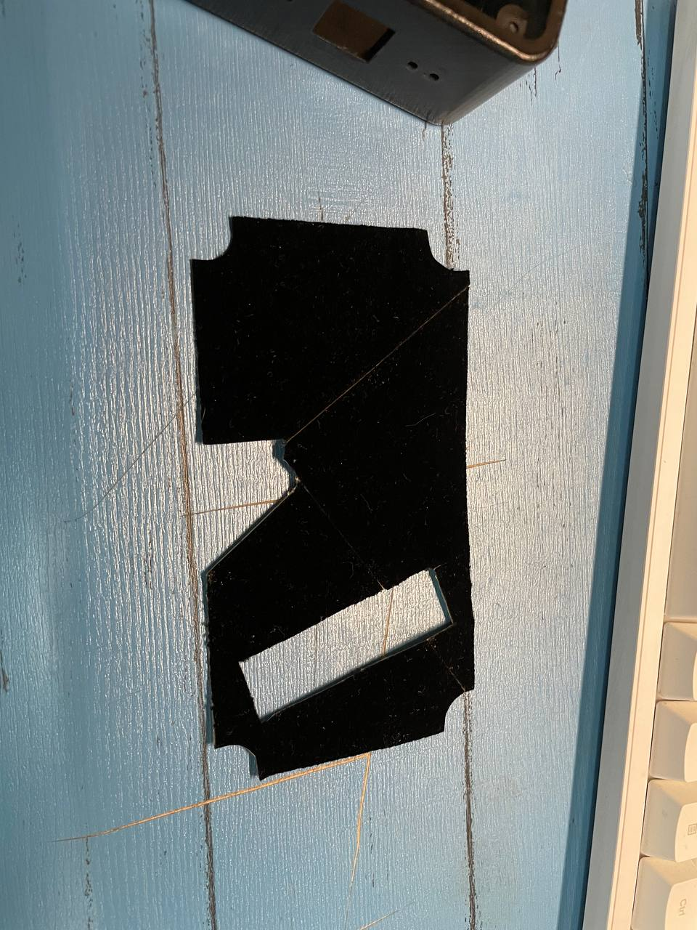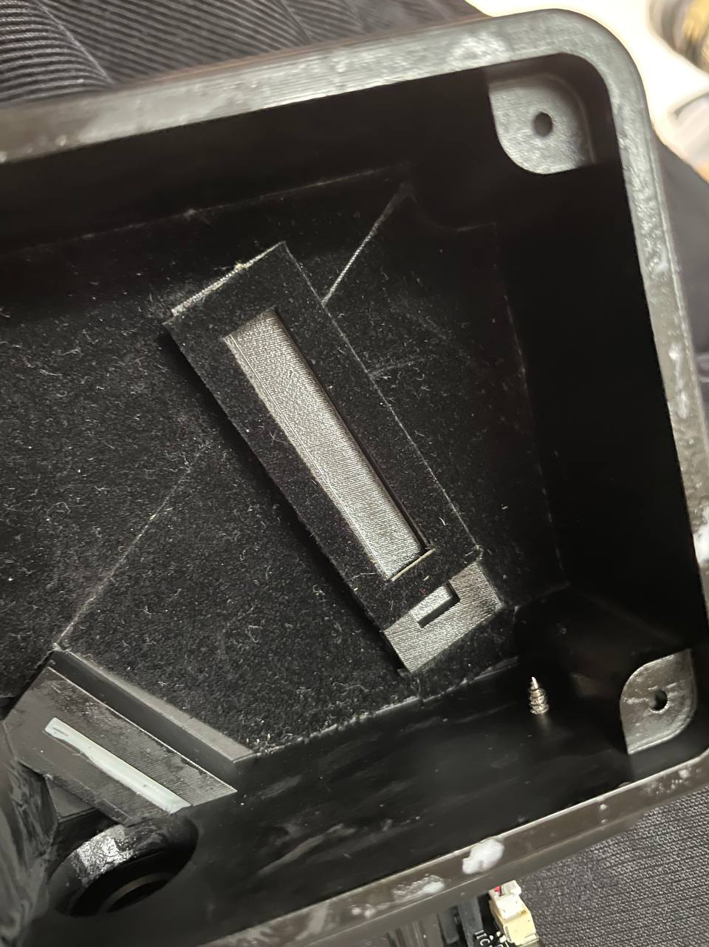

Figure ‑

(Photo of pasting sticker)

* When you decided to disassemble a camera to fit in the project, be careful with the thermal, use the cooling fin to protect the chip and CMOS on the PCB.

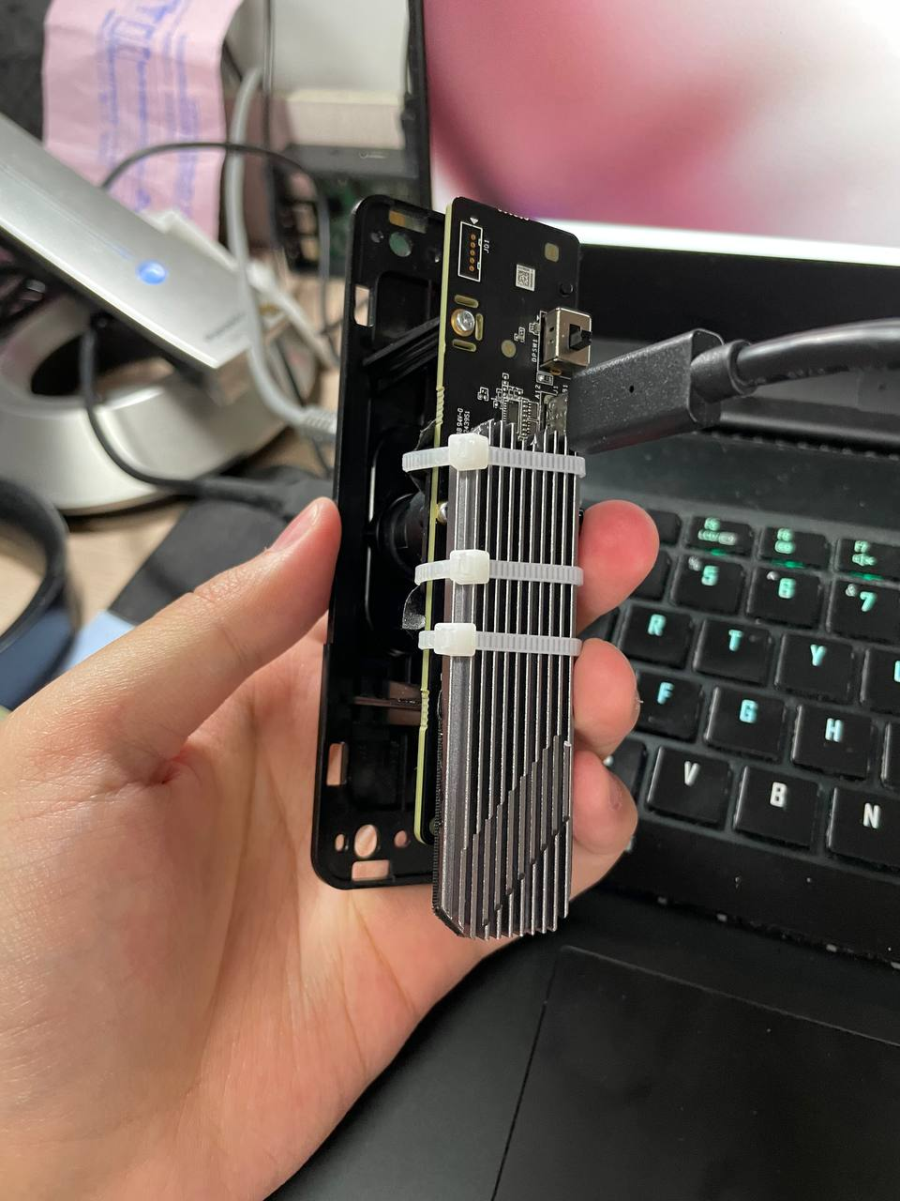

Figure ‑

(Photo of assembling cooling solution)

## Software Building and Calibration

Software always comes after the hardware, but still essential. Without the data processing and calibration, a well-designed spectrometer is just a fancy brick. There are actually lots of spectrometer analysis software whether opensource or proprietary, but for a low budget project, thousands of dollar’s licences for the software are not acceptable, and free opensource ones may not satisfy the requirement. So, building data analysis software is still important.

### Data Capture and Processing

With the Python language and massive opensource library, capturing image data from a webcam and processing it is quite simple with the following steps:

* Import the OpenCV library, using the cv2.VideoCapture() function to get the image metrics from the camera.
* Import NumPy library, using the linear distribution algorithm mentioned in Section 2.3 to produce an adjusted x-axis.
* Using NumPy again, implement the colour space transformation algorithm mentioned in Section 2.4 to get the relative luminance result
* Import the matplotlib library, using it to plot the resulting diagram.

### Linear Calibration

In Section 2.3, we obtained the spectrum linear distribution Equation 2‑21, theoretically, if we fill the parameter that we designed on the paper, we could obtain the perfect spectrum-to-wavelength-mapping result. However, due to the inaccuracy in the component fabrication and assembly, there will be error introduced to the system and make the result inaccurate. For example, in the following Figure 3‑16 and Figure 3‑17, the yellow D-lines (588.9 and 589.5 nm) [20] of the sodium emission is shifted to around 500 nm, which is not correct.

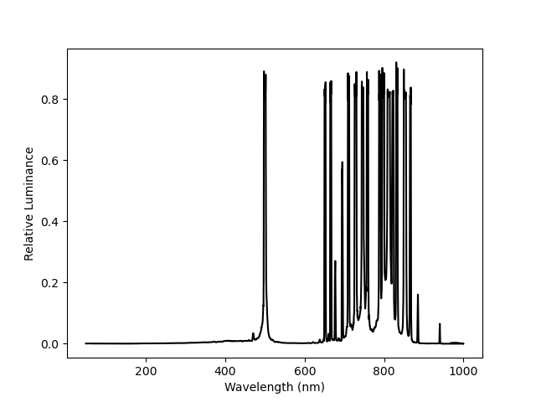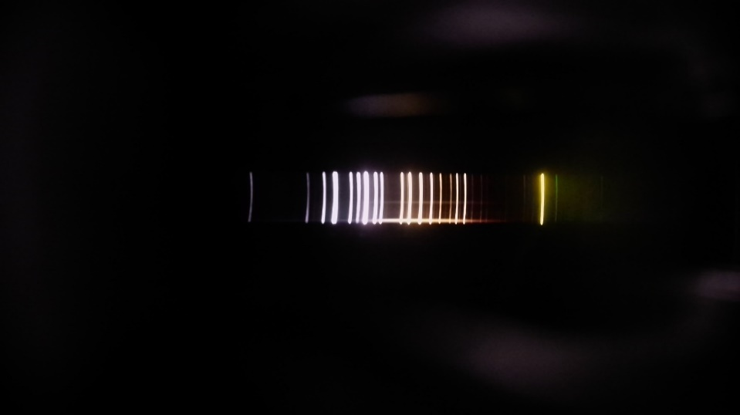

Figure ‑

(Sodium lamp spectrum)

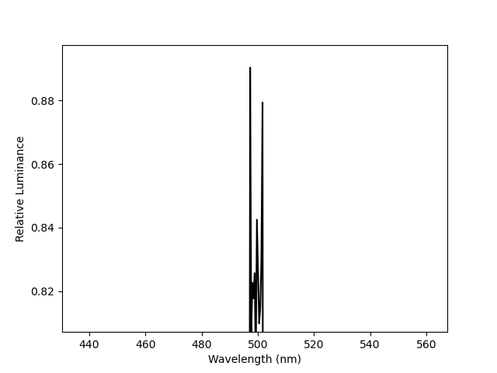

Figure ‑

(Zoom in on Figure 3‑16)

To fix this problem, we could use serval monochromatic lasers with known wavelength to measure the spectrum deviation distance, make simultaneous equations and using the estimation algorithm to find an approximate solution for the nonlinear equations. Usually, at least three different lasers are required, and more lasers could improve the accuracy more.

In this case, a 532/808 nm laser diode, a 640 nm laser diode and a 632.8 helium-neon gas laser is used. The test result is in Figure 3‑18 and Table 3‑1.

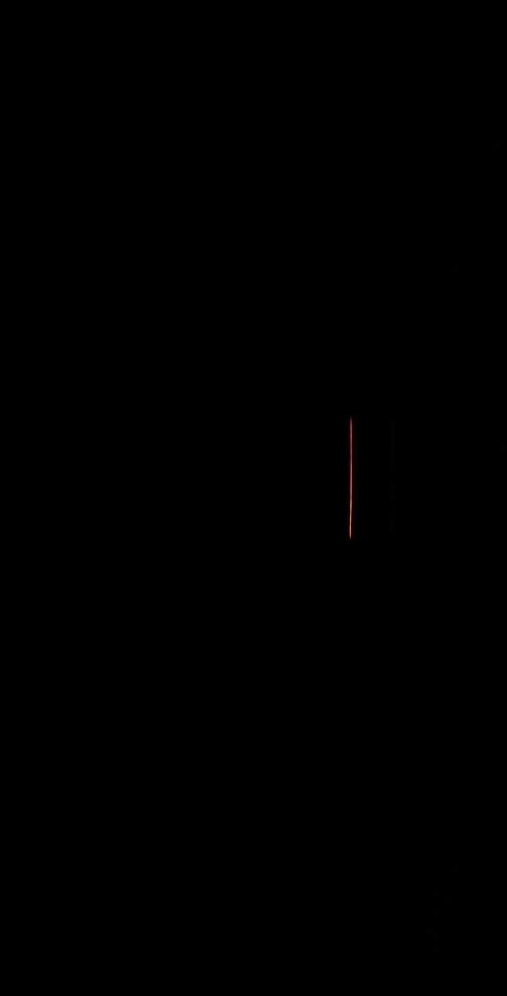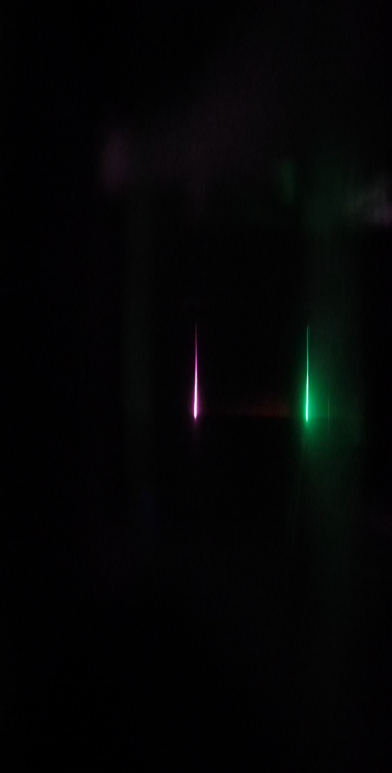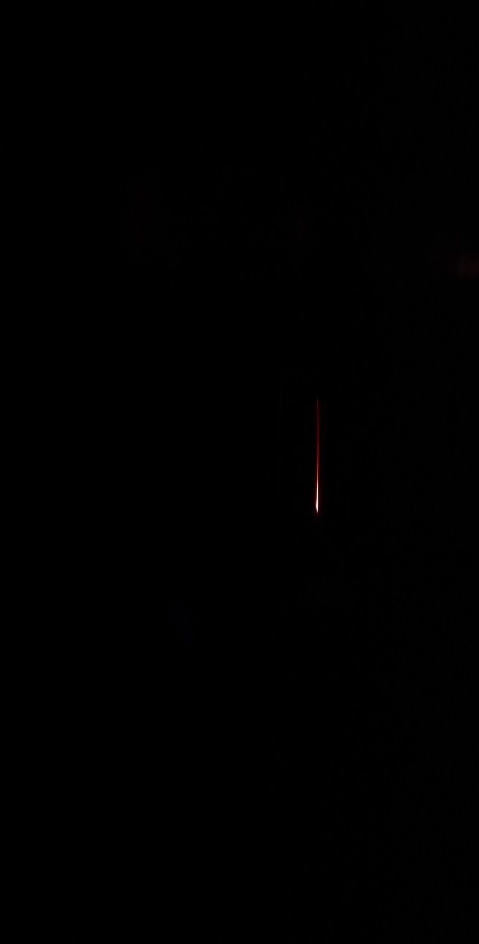

Figure ‑

(From top to down is 532 nm, 632.8 nm, and 650 nm laser spectrum)

|  |  |
| --- | --- |
| Wavelength ($λ_{i}$) | Pixel Position (start from zero) ($PP$) |
| 532 nm | 827 |
| 808 nm | 1919 |
| 632.8 nm | 1179 |
| 650 nm | 1289 |

Table ‑

(Data for calibration algorithm)

After getting the data of the 4 standard spectrum line, we could start calibration processing.

According to Equation 2‑21, assume that $∆x=k_{i}$, $q=F_{L_{2}}∙φ$ and $\frac{λ_{i}}{d}=b_{i}$, and as what has been mentioned in Section 3.1, $k=1$, $d = 1000 lines/mm$, $∆x=\left|PP-1920\right|*{6.4}/{3840} mm$. Then we have:

(‑)

Here, it is considered that $b_{i}$ is completely known parameters and $α$ is approximately estimated to be between $0°\sim 3°$ due to the design limitation. Then expressions of $q$ and $F_{L_{2}}$ could be expressed as follows:

(‑)

(‑)

Where , and $q^{*}$ are the estimation value for realistic simulation.

For getting more accurate results, an estimation algorithm is utilized as follows:

* Assume that $α=\{0°, 0.1°, …,3°\}$.
* For each defined $α$, a series of values of $q$ could be obtained.
* Choose the series that has the least variance and determine the corresponding $α$ as $α^{*}$.
* Get the mean value $q^{*}$ of chosen $q$ series for realistic simulation.
* Obtain a series of $F_{L_{2}}$, and get those mean $F_{L_{2}}^{*}$ for realistic simulation.

And then, implemented the algorithm to the Matlab, and obtain the approximate solution of incident angle $α$, camera angle $φ$ and focal length $F_{L_{2}}$. In this case, the corrected focal length of the camera $F_{L_{2}}$ is $4.784 mm$, which is far from the $3.6 mm$ on the specification sheet, this may indicate the specification sheet from the deal is not correct. And the calibration for angle $α$ is still zero and camera angle $φ$ is $0.942$, which is slightly shift, may cause by the error in the assembling process.

# Discussion and Results

After all the hard work, the finished spectrometer is accomplished (see Figure 4‑1).

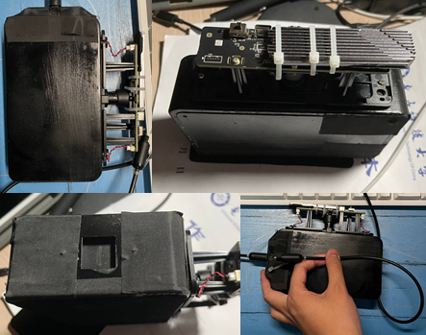

Figure ‑

(Final assembled spectrometer)

Then various light sources are measured by the spectrometer to test the performance and validate the design goal (see Figure 4‑2).

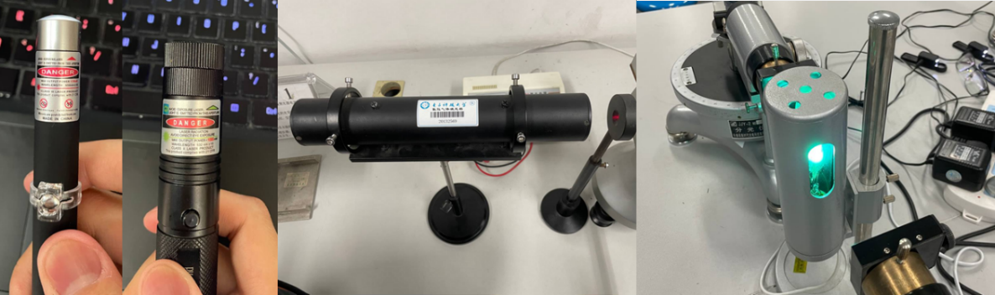

Figure ‑

(From left to right is 650 nm, 532 nm laser pen, 632.8 nm He-Ne laser and mercury lamp)

## Result of the Measurement

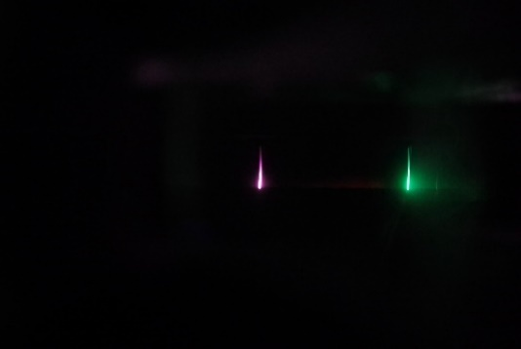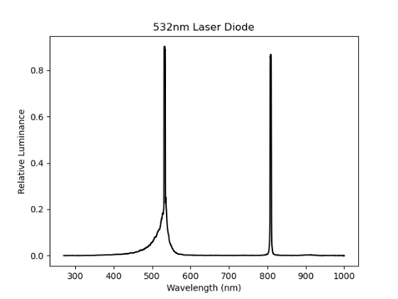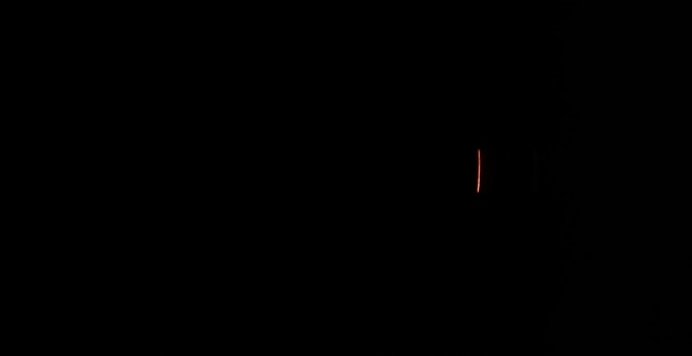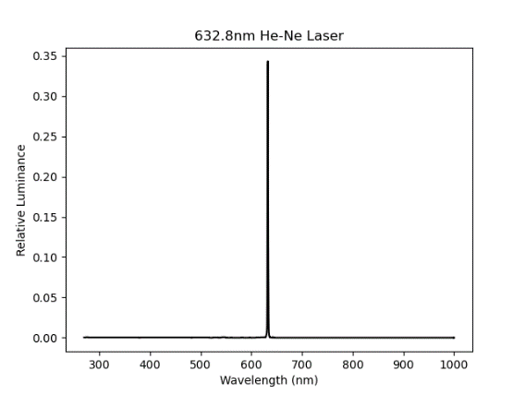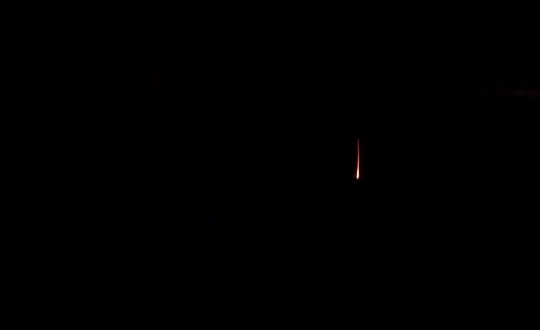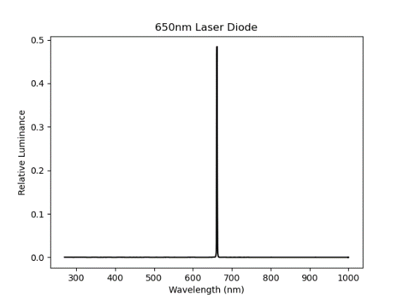

Figure ‑ (a) (b) (c)

(Three Lasers’ Result)

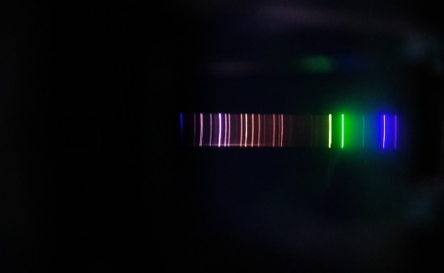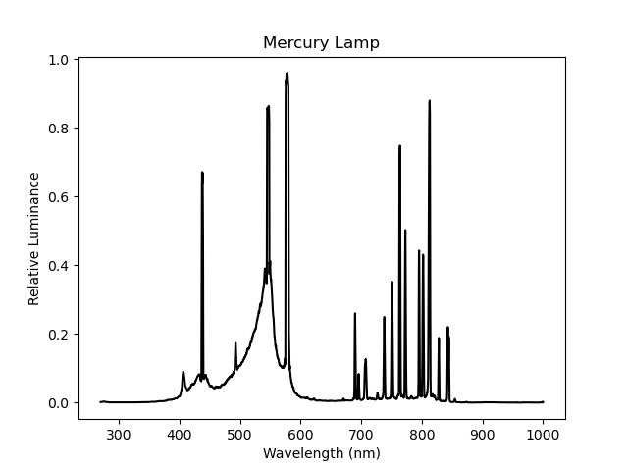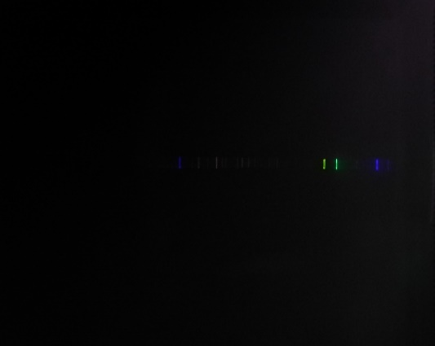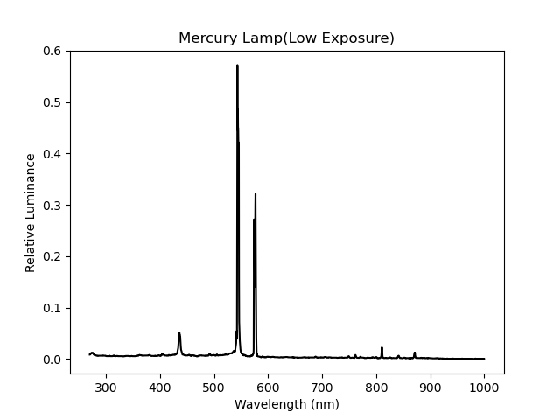

Figure ‑ (a) (b)

(Mercury Lamp’s Result)

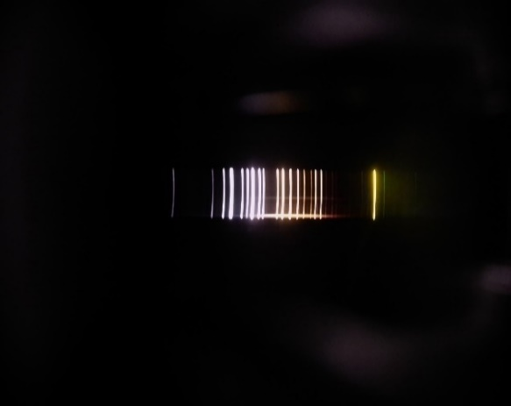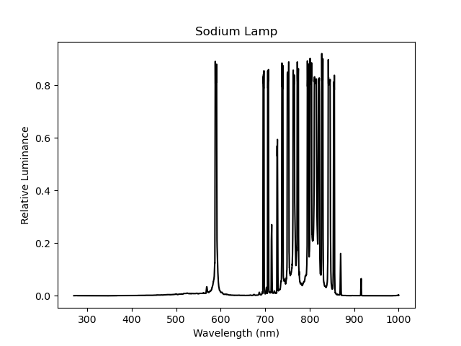

Figure ‑

(Sodium Lamp’s Result)

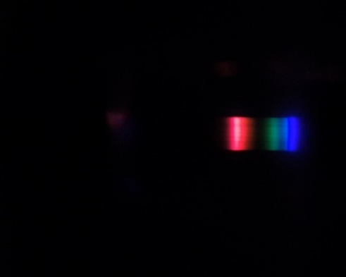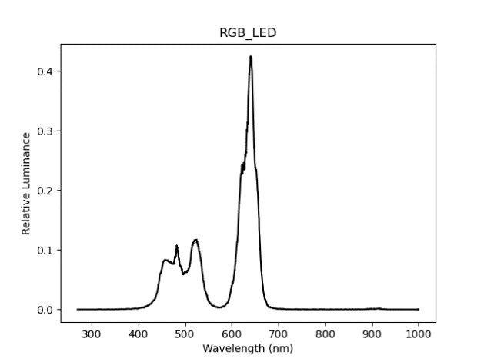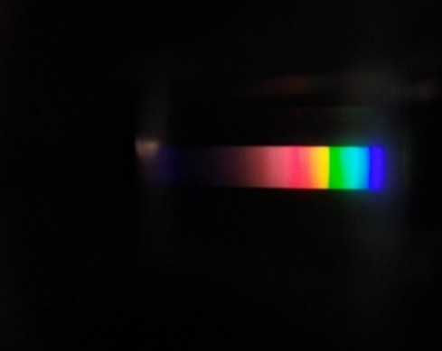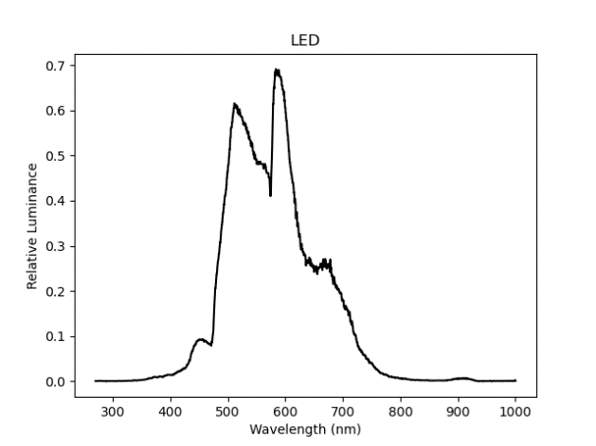

Figure ‑ (a) (b)

(Result of two kinds of the LED)

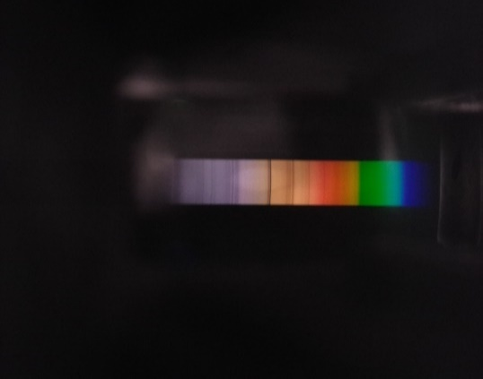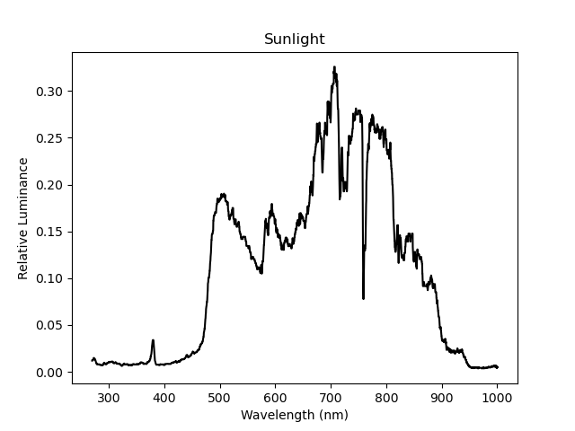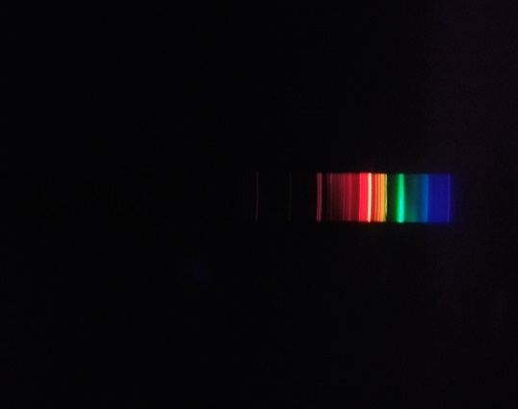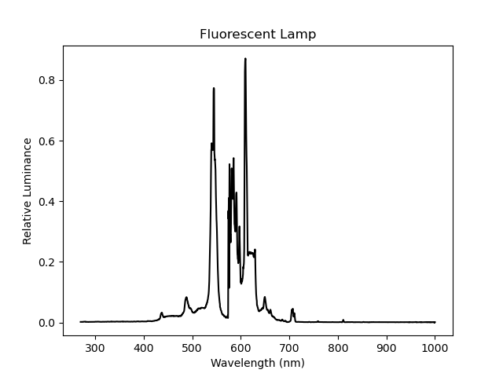

Figure ‑ (a) (b)

(Result of sunlight and fluorescent Lamp)

## Verification of the Project

If we zoom at Figure 4‑4 (b) in around 575 nm and Figure 4‑5 in around 590 nm, we could clearly see the double spectrum in both diagrams, they are the double green lines in the mercury emission spectrum (576 and 579 nm) [21] and D-lines (588.9 and 589.5 nm) [20] in sodium emissions spectrum. And it indicates the spectrometer has more than 1nm accuracy and satisfied the design objective.

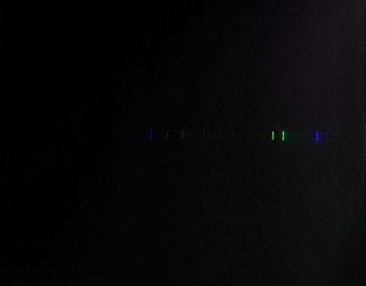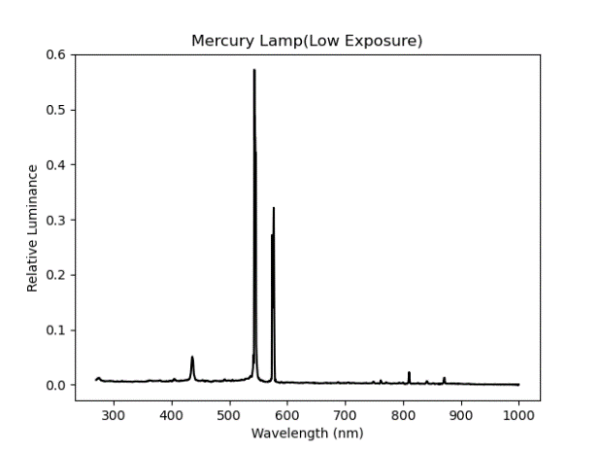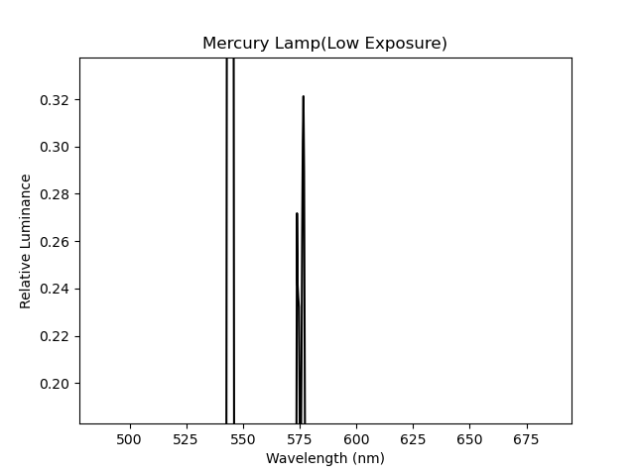

Figure ‑

(Zoom-in of Mercury Lamp’s Result)

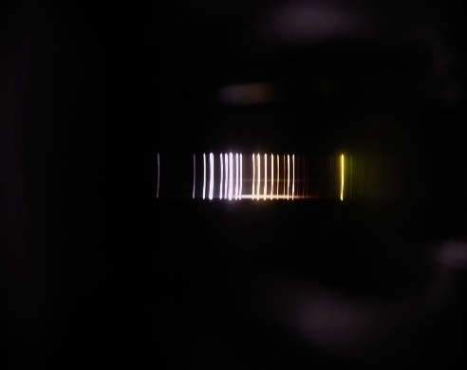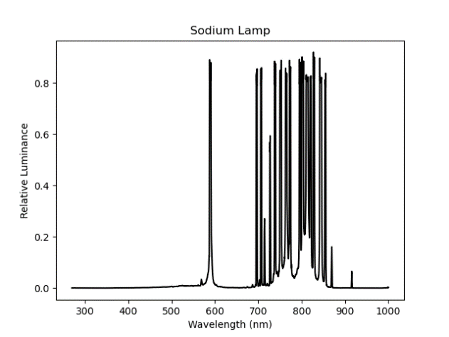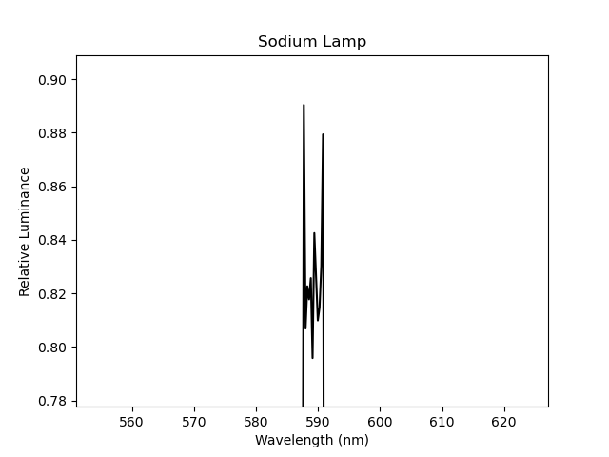

Figure ‑

(Zoom-in of Sodium Lamp’s Result)

Then see Figure 4‑7 (a) of the sunlight spectrum, it is obvious to see that the spectrometer’s effective wavelength range is covered from around 350 to 950 nm, which is closed to the design goal of 400 to 1000 nm.

# Conclusions and further work

## Conclusions

In conclusion, a high-resolution optical spectrometer and accessory software has been successfully designed and build within a low budget. And the design goals of resolution and wavelength coverage are achieved.

## Suggestions for further work

The luminance data from the software is relative luminance which only represents the percentage between maximum and minimum sensitivity and not the physics luminous flux. To get this value, we could use some standard light source to calibrate the spectrometer, so that the percentage could be mapping to the luminous flux. However, a standard light source usually cost a lot, may cause over budget, and there is not one that could be borrowed on my campus. So, it is considered to be the done in the future work.

# Reference

|  |  |
| --- | --- |
| [1] | Ocean Insight, "Spectrometers," [Online]. Available: https://www.oceaninsight.com/products/spectrometers/. [Accessed 20 4 2021]. |
| [2] | G. Mu and Y. Zhan, "Huygens–Fresnel principle," in *Optics*, Second Edition ed., Bejing, Higher Eduation Press, 2009, pp. 195-196. |
| [3] | G. Mu and Y. Zhan, "Diffraction Grating," in *Optics*, Second Edition ed., Bejing, Higher Eduation Press, 2009, pp. 237-254. |
| [4] | G. Mu and Y. Zhan, "Fraunhofer Single Slit Diffraction," in *Optics*, Second Edition ed., Beijing, Higher Eduation Press, 2009, pp. 214-218. |
| [5] | Doubtnut, "Find the angular width of the central maxima of Fraunhofer diffraction pattern due to single slit.," 18 2 2020. [Online]. Available: https://www.doubtnut.com/question-answer-physics/describe-with-a-neat-labelled-ray-diagram-the-fraunhofer-diffraction-pattern-due-to-a-single-slit-ob-96606473. [Accessed 20 4 2021]. |
| [6] | D. Tim, "Tomographic reconstruction of combined tilt- and focal series in scanning transmission electron microscopy," *ResearchGate,* 1 2015. |
| [7] | G. Mu and Y. Zhan, "Rayleigh Criterion," in *Optics*, Second Edition ed., Bejing, Higher Eduation Press, 2009, pp. 224-226. |
| [8] | A. Scheeline, "How to Design a Spectrometer," *Applied Spectroscopy,* 17 7 2017. |
| [9] | S. G. Djorgovski, "Spectrographs and Spectroscopy," Fall 2012. [Online]. Available: https://sites.astro.caltech.edu/~george/ay122/Ay122a_Spectroscopy.pdf. [Accessed 19 4 2021]. |
| [10] | BenRG, "CIE 1931 xy color space diagram," 24 09 2009. [Online]. Available: https://commons.wikimedia.org/wiki/File:CIExy1931.png. [Accessed 20 04 2021]. |
| [11] | International Electrotechnical Commission, "Multimedia systems and equipment - Colour measurement and management - Part 2-1: Colour management - Default RGB colour space - sRGB," 1999. |
| [13] | Ibsen, "Spectrometer Design Guide," [Online]. Available: https://ibsen.com/technology/spectrometer-design-guide/. [Accessed 15 4 2021]. |
| [14] | University of Technology - IRAQ, "Measure the Distance Between Tracks of CD and DVD," [Online]. Available: https://uotechnology.edu.iq/dep-laserandoptoelec-eng/laboratory/4/laser%20application/exp3.pdf. [Accessed 20 4 2021]. |
| [15] | Alibaba, "Price of MILC camera," [Online]. Available: https://2.taobao.com/. [Accessed 20 4 2021]. |
| [16] | SONY Inc., "α5000 E-mount Camera with APS-C Sensor," [Online]. Available: https://www.sony.com.tw/en/electronics/interchangeable-lens-cameras/ilce-5000-kit. [Accessed 2 4 2021]. |
| [17] | Nikon Corporation, "Nikon 1 J1," [Online]. Available: https://www.nikon.com.cn/sc_CN/product/discontinued/nikon-1/nikon-1-j1. [Accessed 20 4 2021]. |
| [18] | HIKVISION Inc., "HIKVISION 4K Webcam DS-2CS54U0B-SD," [Online]. Available: https://item.jd.com/63194517050.html. [Accessed 20 4 2021]. |
| [20] | University of California, Irvine, Department of Chemistry, "The sodium D-lines," [Online]. Available: https://www.chem.uci.edu/~unicorn/249/Handouts/RWFSodium.pdf. [Accessed 21 4 2021]. |
| [21] | C. J. Sansonetti, M. L. Salit and J. Reader, "Wavelengths of spectral lines in mercury pencil lamp," *Applied Optics. 35,* pp. 74-77, 1996. |

# Appendices

## Specification list

* Diffraction Grating: size: $20*20*2 mm$, linear density:1000 lines/mm, material: float glass
* Camera: resolution: $3840*2160$, sensor size: $6.4*3.6 mm$, lens’ focal length: $3.6 mm$ in spec, actually $4.76 mm$, aperture size: f/1.6.
* Collimator Mirror: size: $50*25.4*6.7 mm$, focal length: $110mm$, radius of curvature: $220mm$.
* Single slit: size: 2 $0*20*0.1 mm$, slit size: $15*0.1mm$, material: steel.

## Component list

|  |  |
| --- | --- |
| Name of component | Price with shipping fee (CNY) |
| Diffraction Grating | 165 |
| Collimator Mirror | 105 |
| Steel Single Slit | 125 |
| Camera | 499 |
| 3D Printed Case | 285 |
| Optical Fibre | 20 |
| Lasers | 70 |
| Overall | 1269 |

Table ‑

(Component list)

## List of Figure

Figure 2‑1 10

Figure 2‑2 10

Figure 2‑3 [3] 11

Figure 2‑4 [4] 13

Figure 2‑5 [5] 14

Figure 2‑6 [6] 15

Figure 2‑7 16

Figure 2‑8 [8] 17

Figure 2‑9 17

Figure 2‑10 [10] 19

Figure 3‑1 20

Figure 3‑2 22

Figure 3‑3 [14] 23

Figure 3‑4 [16] [17] 24

Figure 3‑5 [18] 24

Figure 3‑6 [19] 25

Figure 3‑7 26

Figure 3‑8 26

Figure 3‑9 26

Figure 3‑10 27

Figure 3‑11 27

Figure 3‑12 28

Figure 3‑13 28

Figure 3‑14 28

Figure 3‑15 29

Figure 3‑16 30

Figure 3‑17 30

Figure 3‑18 31

Figure 4‑1 33

Figure 4‑2 33

Figure 4‑3 (a) (b) (c) 33

Figure 4‑4 (a) (b) 34

Figure 4‑5 34

Figure 4‑6 (a) (b) 34

Figure 4‑7 (a) (b) 35

Figure 4‑8 35

Figure 4‑9 35

## List of Equation

(2‑1) 11

(2‑2) 11

(2‑3) [4] 12

(2‑4) [4] 12

(2‑5) [4] 12

(2‑6) [4] 12

(2‑7) 13

(2‑8) 13

(2‑9) [4] 13

(2‑10) 14

(2‑11) [4] 14

(2‑12) [7] 15

(2‑13) 15

(2‑14) 16

(2‑15) 16

(2‑16) 16

(2‑17) 16

(2‑18) 18

(2‑19) 18

(2‑20) 18

(2‑21) 18

(2‑22) [11] 19

(2‑23) [11] 19

(3‑1) 21

(3‑2) 21

(3‑3) 21

(3‑4) 21

(3‑5) 21

(3‑6) 31

(3‑7) 31

(3‑8) 31

## Code

### Main Program

1. import cv2
2. import numpy as np
3. from matplotlib import pyplot as plt
4. def linear(u):
5. if u < 0.04045:
6. gamma = 25 * u / 323
7. else:
8. gamma = pow(((200 * u + 11) / 211), (12 / 5))
9. return gamma
10. cap = cv2.VideoCapture(2)
11. while (1):
12. # get a frame
13. ret, frame = cap.read()
14. # show a frame
15. cv2.imshow("capture", frame)
16. if cv2.waitKey(1) & 0xFF == ord('q'):
17. break
18. cap.release()
19. img = frame
20. col, row, a = img.shape
21. col2 = col // 2
22. img2 = img.astype(float)[col2, :, :]
23. for x in range(row):
24. for y in range(a):
25. img2[x, y] = linear(img2[x, y] / 255)
26. convert_XYZ = np.array([[0.4124, 0.3576, 0.1805], [0.2126, 0.7152, 0.0722],
27. [0.0193, 0.1192, 0.9505]])
28. XYZ = np.dot(convert_XYZ, np.fliplr(img2).T)
29. sensor_w = 6.4
30. F_L2 = 4.784575119803315
31. phi = 0.942087992419107
32. alpha = 0
33. d = 1000
34. k = 1
35. pixel_w = sensor_w / row
36. x = np.arange(0, row)
37. x_1 = np.flipud(
38. (np.sin((x - (row / 2)) * pixel_w / F_L2 + phi) + np.sin(alpha)) * d / k)
39. print(XYZ)
40. Y = XYZ[1, :]
41. B = img[col2, :, 0] / 255
42. G = img[col2, :, 1] / 255
43. R = img[col2, :, 2] / 255
44. """ plt.plot(x_1, B, color='blue', label='blue')
45. plt.plot(x_1, G, color='green', label='green')
46. plt.plot(x_1, R, color='red', label='red') """
47. plt.plot(x_1, Y, color='black', label='luma')
48. plt.show()

### Matlab Codes for Figure 3‑2

1. %% caculating effective indeicent angle
2. d = 1000;
3. theta_1 = 0:0.001:pi / 2;
4. lambda_1 = 300;
5. lambda_2 = 1000;
6. lambda_3 = 635;
7. theta_2 = asin(sin(theta_1) - (lambda_1) / d);
8. theta_3 = asin(sin(theta_1) - (lambda_2) / d);
9. theta_4 = theta_2 - theta_3;
10. figure(1);
11. plot(theta_1, theta_4, 'LineWidth', 2);
12. xlabel("Incident Angle (rad)");
13. ylabel("Diffraction Angle Difference (rad)")

### Matlab Codes for estimation algorithm in Section 3.6.2

1. %this code is for estimation algorithm for linear callibration
2. L=[532 632.8 808 532];
3. b=L/1000;
4. PP=[827 1179 1919 827];
5. k=abs(PP-1920)*6.4/3840;
6. a=0:0.1:3;
7. a=a*pi/180;
8. q=zeros(3,31);
9. for i=1:3
10. for j=1:31
11. q(i,j)=(k(i)*asin(b(i+1)-sin(a(j)))-k(i+1)*(asin(b(i)-sin(a(j)))))/(asin(b(i+1)-sin(a(j)))-asin(b(i)-sin(a(j))));
12. end
13. end
14. Variance=zeros(1,31);
15. for j=1:31
16. Variance(j)=var(q(:,j));
17. end
18. [min_value,min_position]=min(Variance);
19. q_estimation=q(:,min_position);
20. q_mean=sum(q_estimation)/3;
21. F=zeros(1,3);
22. for i=1:3
23. F(i)=(q_mean-k(i))/asin(b(i)-sin(a(min_position)));
24. end
25. F_mean=mean(F);
26. phi=q_mean/F_mean;